Tablet Mechanism - Integrated Prototype

# Introduction

After iteration and evaluation of prototypes, we decided as a team to move forward with the parallel open-linkage arm to actuate the 4 degrees of freedom necessary. We as a team felt that it outperformed the other concepts we prototyped, particularly in regards to the minimal friction in the rotary joints as well as the ease of control as well.

Following is discussion of design choices for the prototype as well as the results in the form of qualitative observations as well as a more formal analysis in the context of the device requirements. These will then be used to identify key points for future development of the alpha design.

# Prototype & Results

Following the testing with the single, 2R arm on Friday 3/18. We developed a rough CAD model for a linkage system with two 2R arms driven by a system of belts and pulleys, as shown in figure 1.

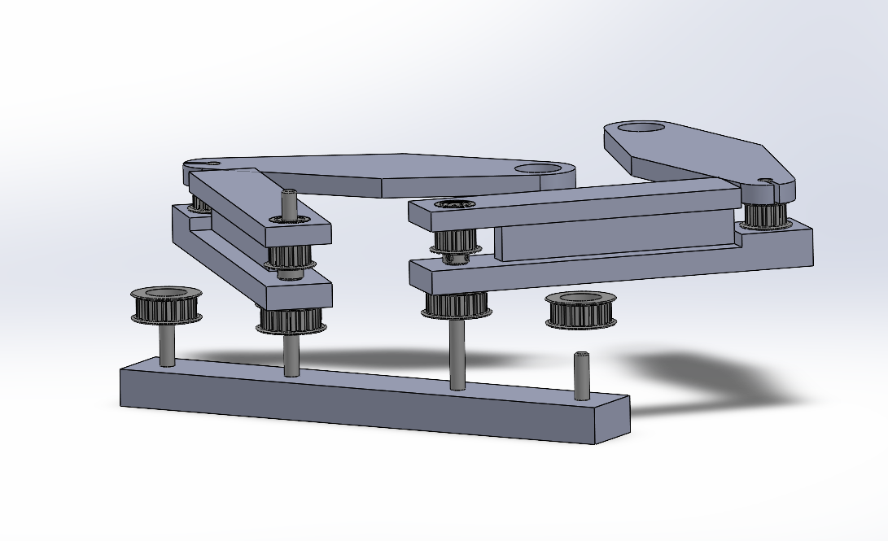

*Figure 1: Concept model for double 2R arm.*

Through discussion, we identified some issues with this design. First, it would be difficult to assemble as is, for there would be no way to install the belt around the second stage pulley system due to the geometry of the base-link. Secondly, it would be very difficult to tension the belt that drives the distal link, for the pulleys are at a fixed distance apart. An idler in the center of the base link that could be cammed outwards to tension the belt was suggested, but this seemed difficult to implement.

Prof. Colgate suggested the possibility of using a 5-bar phantom/parallelogram linkage to eliminate the need for the belt. This eliminated the need for the belt along the base link, as we could control the angle of the distal link through the geometry of the parallelogram. Figure 2 shows the CAD model for the double phantom.

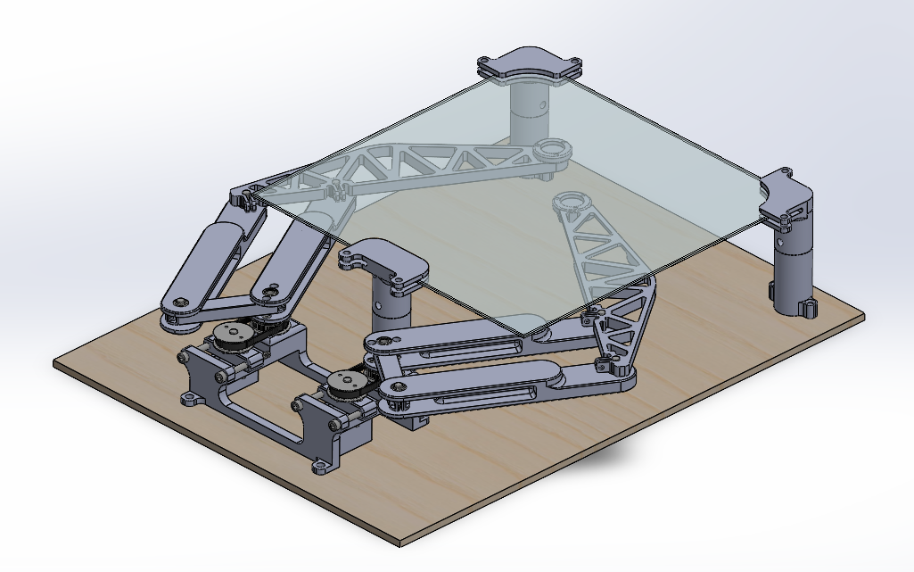

*Figure 2: CAD model of the double phantom prototype.*

As mentioned, the second belt system was eliminated, meaning there was only one belt that needed to be tensioned. There is some added complexity in having additional links, but they are relatively simple parts to design and fabricate using 3D printing. These extra links also add some mass, but we believed that there was enough elimination of friction from the second that it would be smoother in free motion than the 2R arm.

The prototype was fabricated using 3D printing for all of the structures, as this was the easiest and fastest way to create some of the more complicated geometry. The belts and pulleys are of MXL series, 6 mm wide. All bearings are radial ball bearings for 6 mm shaft, and all shafts were made from a single piece of precision ground carbon steel undersized to slightly less than 6 mm. This created a friction slip/friction fit between the shafts and bearings, allowing easy assembly and disassembly. Figures 3, 4, and 5 show the device as manufactured.

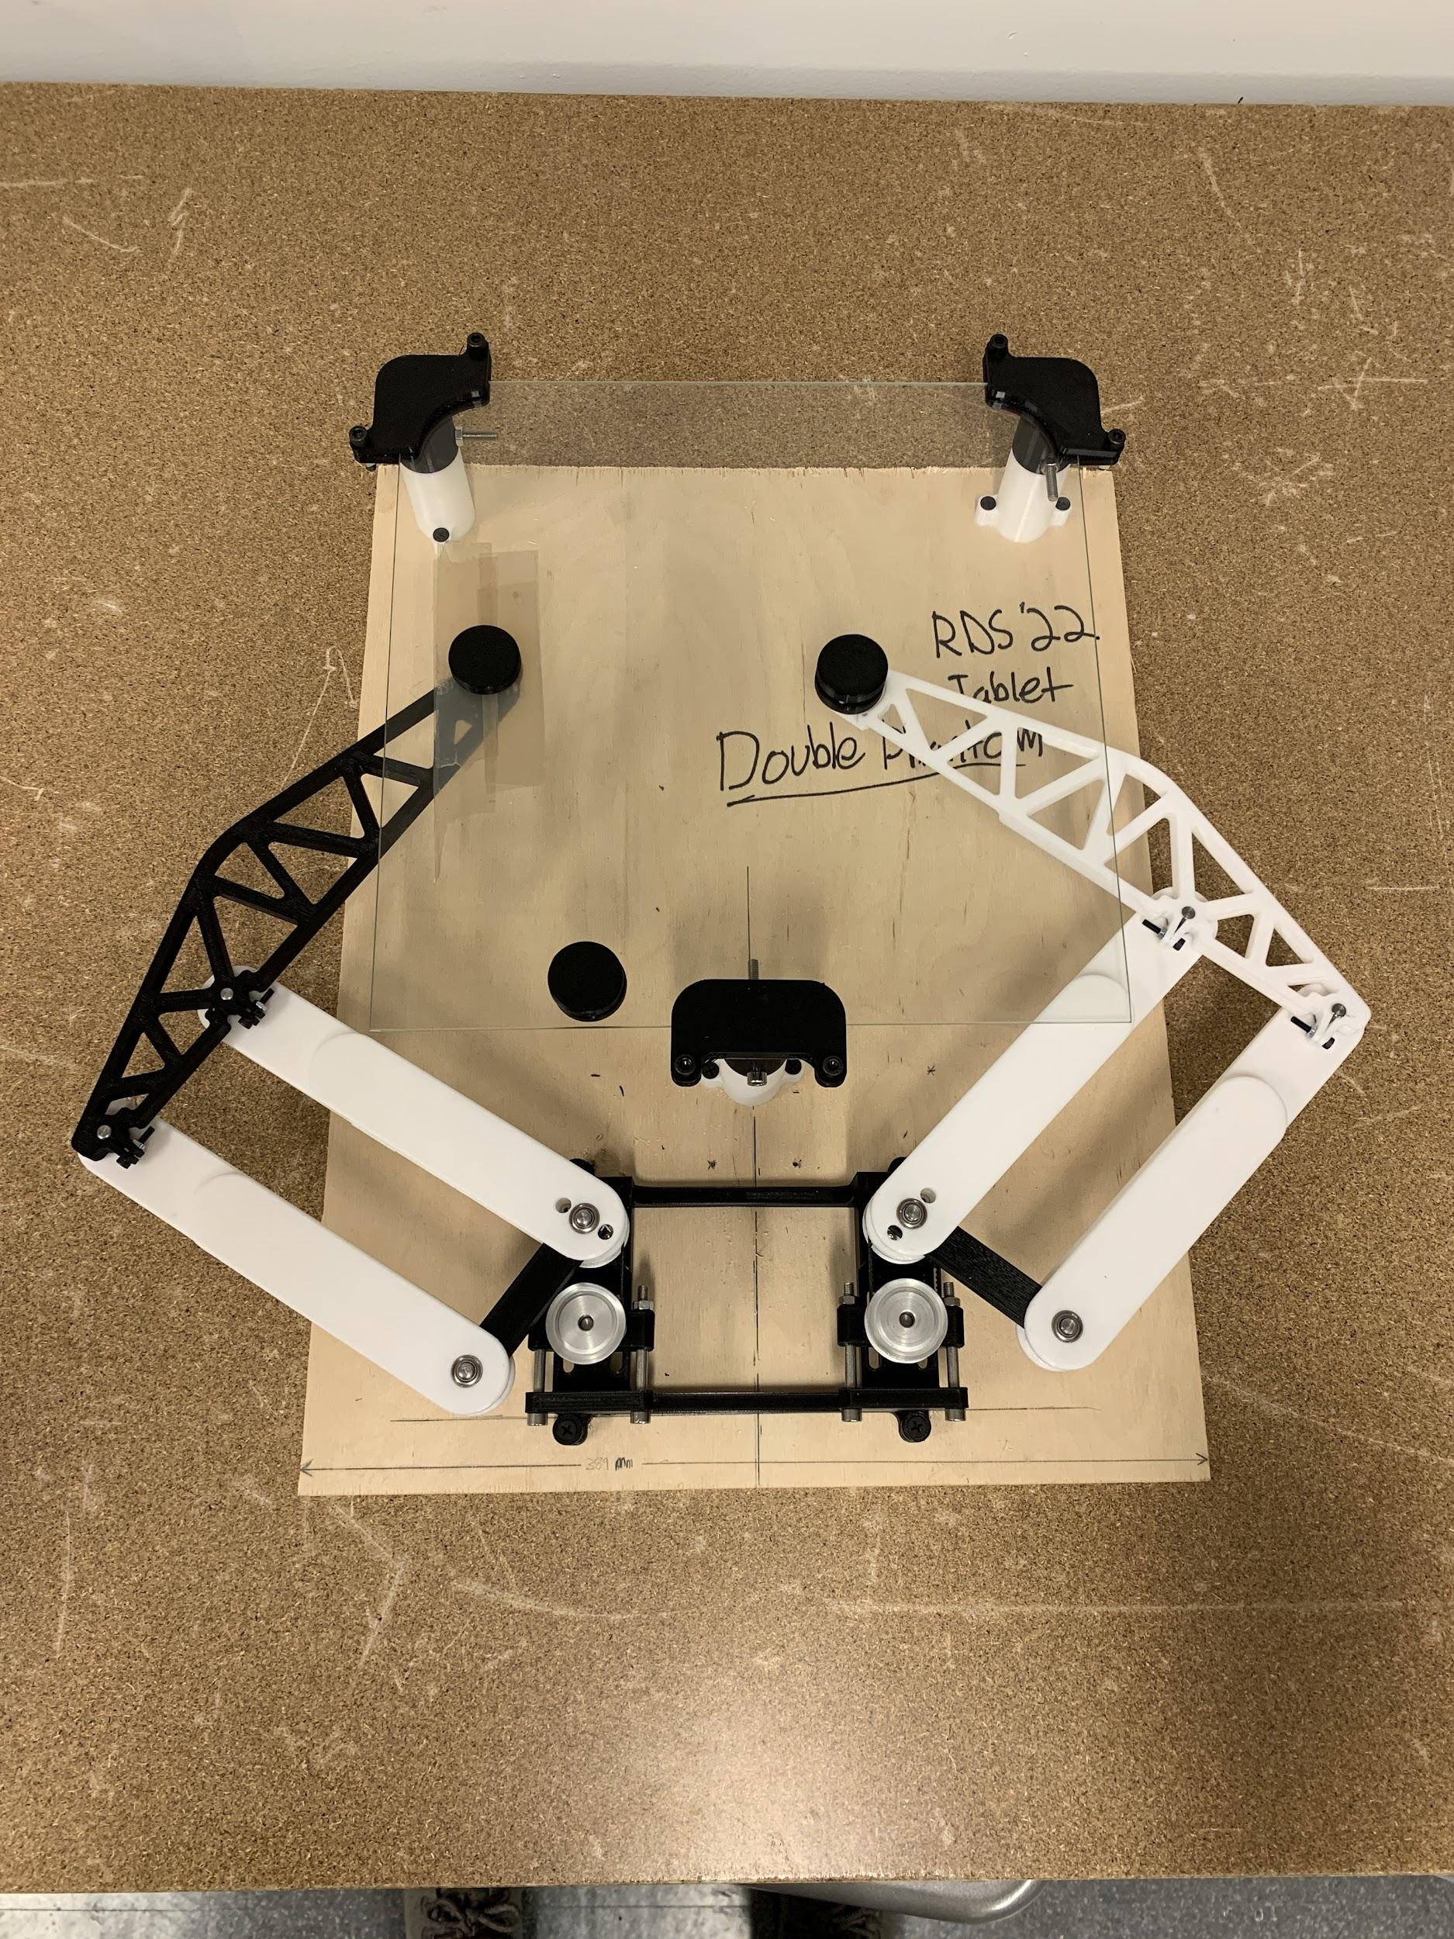

*Figure 3: Top view of assembled double phantom prototype.*

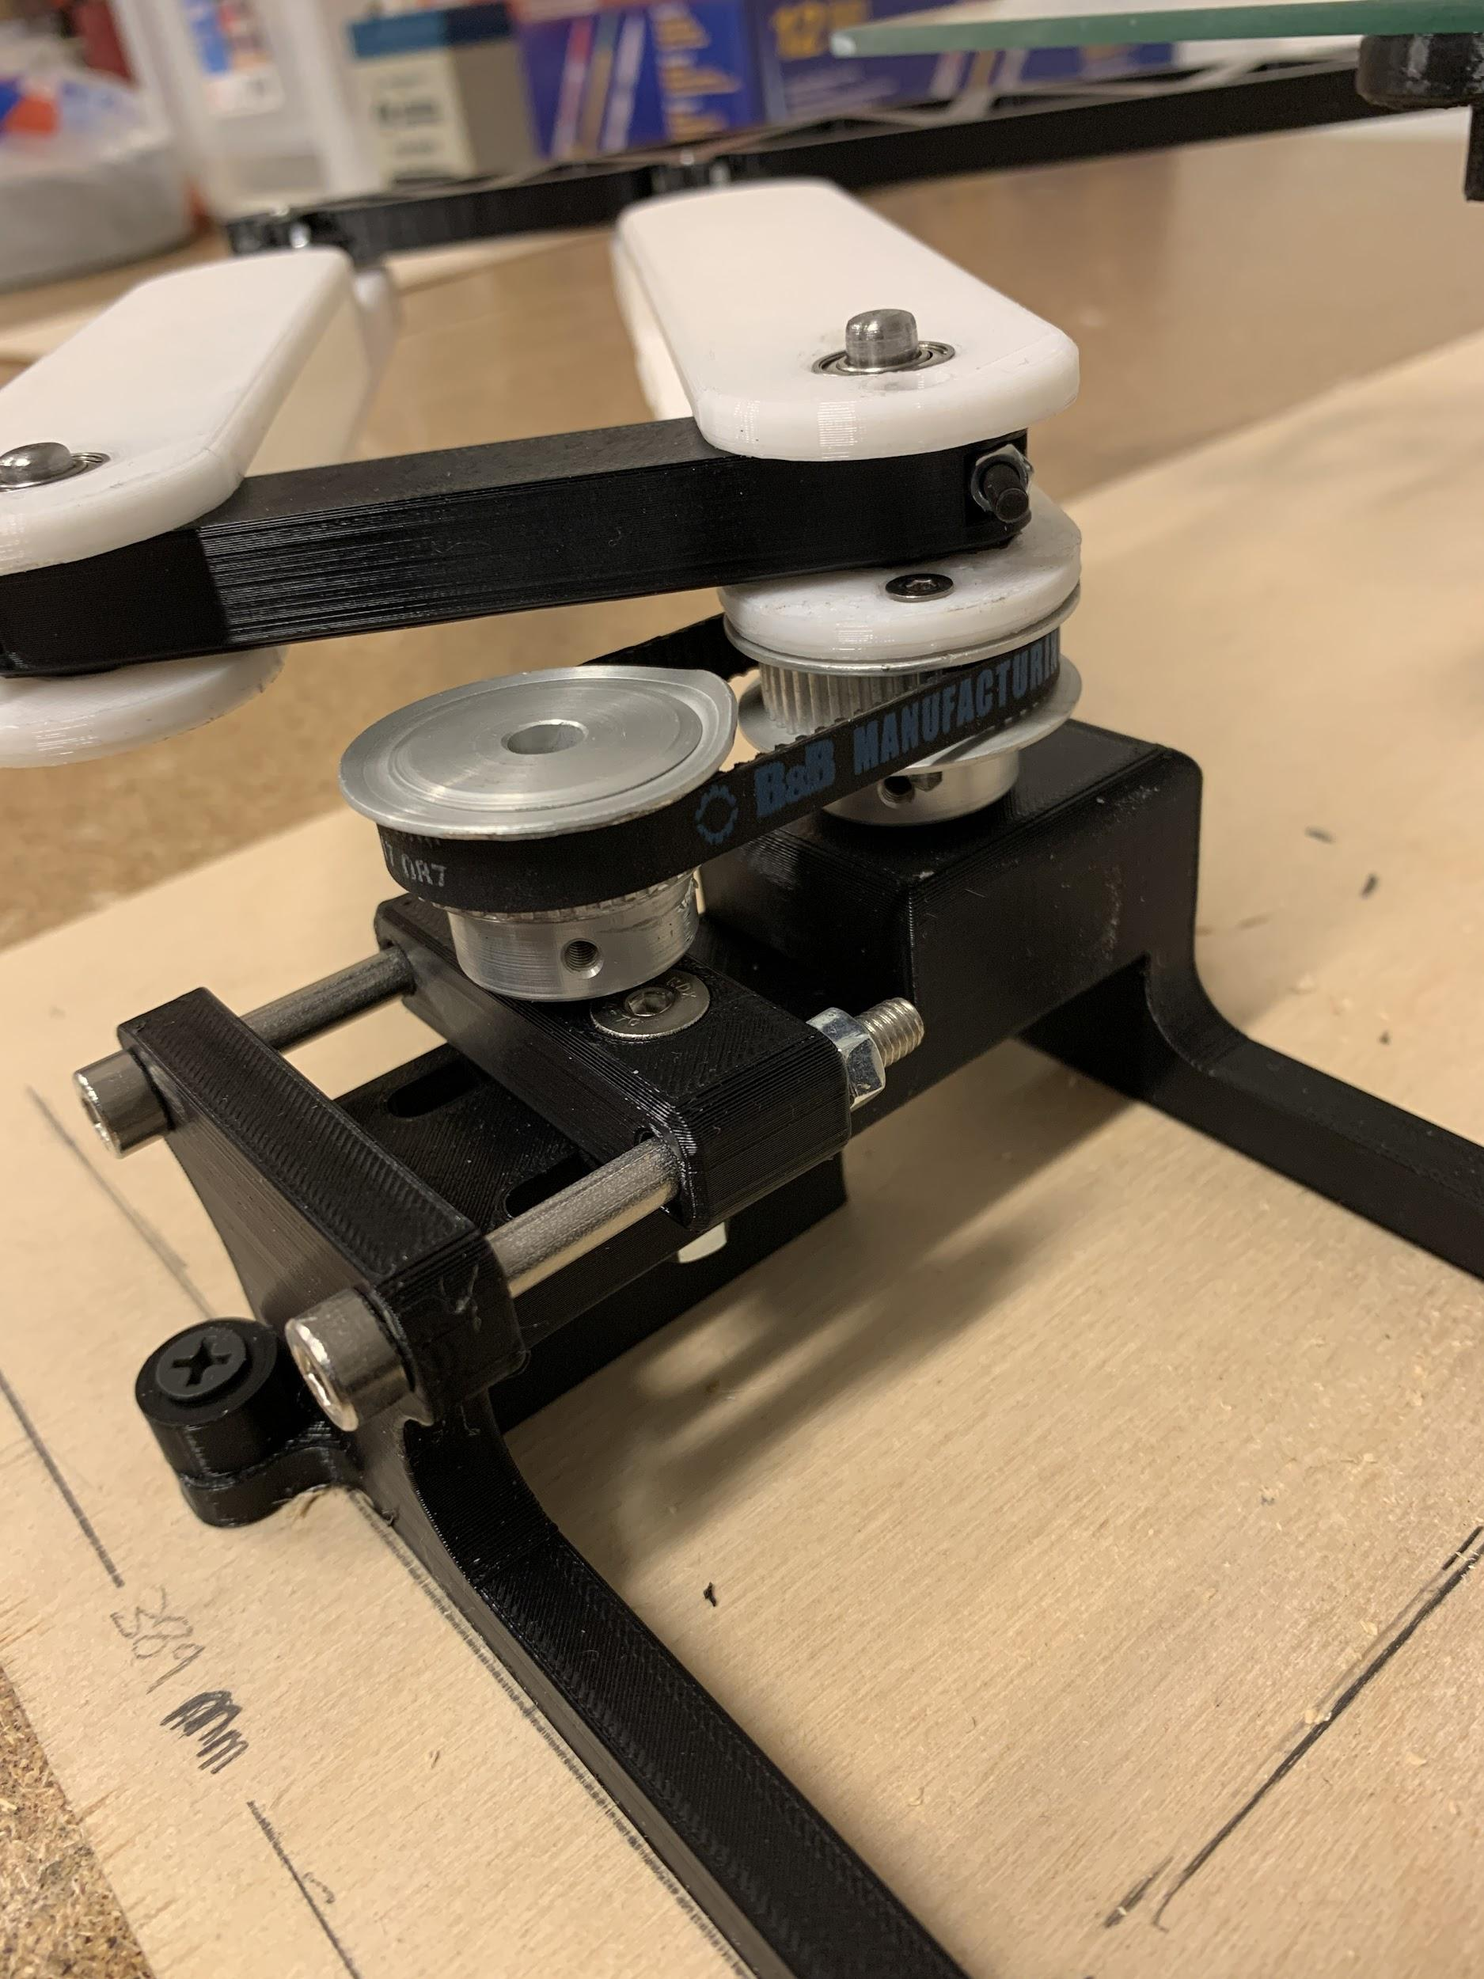

*Figure 4: Detail view of transmission at base of left linkage.*

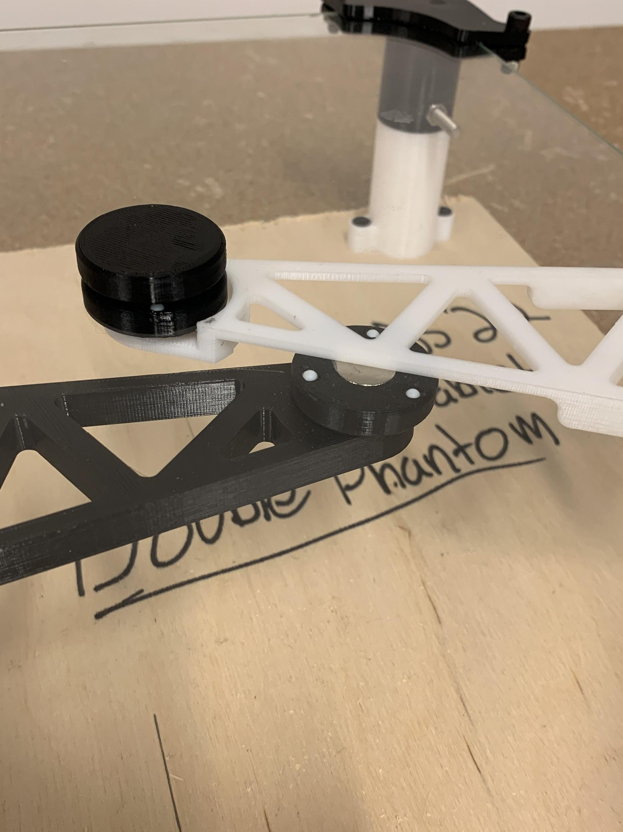

*Figure 5: Detail view of partially overlapping end effectors with integrated magnets.*

With the assembled prototype, the following are some qualitative assessments of it as built after some experimentation and testing:

* Free motion without pseudo-screen and magnets feels fantastic near the center of the workspace. There are some remnants of support structures inside some of the 3D printed links that were difficult to remove and add some friction near the edges of the workspace.
* There is good in-plane stiffness from the structures, but there is relatively little out-of-plane stiffness at the end effector, particularly in the white one with the thinner section for overhang.
* Unloaded, there is some tilting from the vertical of the structures (i.e. they are not parallel to the table). We believe this comes from pressing the bearings into 3D printed structures, as there is less alignment.
* This misalignment in the bearings also adds some friction to the shaft, as it is easy to get through one but difficult to get through another. Need better alignment between bearing axes.
* Tensioning the belt with this system is easy. We were surprised at how much friction even a small amount of friction adds to the rotation of the base link.
* The magnetic attraction pulls the pucks up against the bottom of the glass pseudo-screen. This is fine in the case of the white link, as it is intended to pass over the other one. This is not good for the black link, as it then cannot pass under the white link.
* Magnets with teflon balls have reduced friction, but still nowhere near the level they should be for the free-motion requirements. There is also some low-frequency vibration and jerking as they rub along the glass.
* Magnets can be moved around by pressing with two fingers, just not easily.
* Adding some teflon tape to the glass really helped the feel of the device. The magnets were a lot easier to move around. This is very promising and indicates that the device will feel great with enough friction reduction in the magnets.
* Electromagnets could still be a viable option for this, as it would allow us to control the amount of normal force between the magnets and hence reduce or increase friction as necessary. However, this is more akin to the idea of adding ‘breaks’ to the haptic device, which limits the user’s ability to pull away from a virtual wall.

# 

# Requirements

We also feel as a team that it is important to evaluate our final mechanism prototype against key criteria set early in the course as an objective means of determining its effectiveness. Meeting these requirements will ultimately determine the success of our final device, and it is important to be conscious about not straying too far from them. Hence, the formal analysis is as follows:

**The device shall have a traversable area of at least 7” by 10”.**

The double phantom should have no issues accommodating a screen of this size, as the prototype workspace spans more than the 12” x 12” pane of glass used for the prototype. One note here is that the open linkage requires non-negligible space outside of the workspace in order to reach all points, so as the screen grows, dead space around the screen will grow as well.

**The two contact points shall be able to go as close as 10 mm together or 125 mm apart.**

The double phantom as currently built cannot meet this requirement, mainly due to the size of magnets and the stiffness of the 3D printed linkage parts. The magnets are nearly 10 mm in diameter themselves, so any housing around them pushes us outside the acceptable zone. The overhang geometry in the double phantom can accommodate almost 100 mm of separation, and it is already not stiff enough to smoothly actuate the magnet.

**The two contact points should be able to handle 2 full rotations from a neutral starting point.**

The prototype as is cannot meet this requirement, as there are interferences at the end effector of each linkage that prevent them from crossing. First, the misalignments in the rotary joints (likely due to bearings being pressed into 3D printed parts) as well as the lack of stiffness in the links leads to a stack-up of out-of-plane offsets of the end effectors, leading to interferences. Also, the attractive force of the magnet pulls the module up to the bottom of the screen, meaning that it occupies the same z-height as the overhang and can’t pass under it.

**In free motion, the user should experience no more than 100 grams of inertia.**

Alone, the double phantom mechanism can reach this requirement by just moving around the end-effectors of each arm without magnets. There is enough minimization of friction in the joints that allows smooth enough movement even with the poor tolerances of 3D printed parts adding some friction and misalignment in shafts. By far, the limiting factor is the friction created by the magnets, as this is at least an order of magnitude greater than the friction in the rotary joints of the mechanism.

**In free motion, the gantry device should be able to match finger speeds up to 150 mm/s.**

The phantom mechanism as is can meet this requirement, as there is not enough friction in the joints to damp the user’s motion to the point where 150 mm/s is unachievable. The interaction of the magnets will be the limiting factor in this case, as we have noted often in our testing that the magnets often break their magnetic connection when there is a large impulse on one of them. There is simply too much friction at this time to allow them to reach these speeds freely.

**When the user is interacting with a virtual wall, the device will be able to respond with a stiffness of 1,000 N/m.**  
There are no haptic elements such as virtual walls implemented in mechanism at this time, but the double phantom linkage should be more than able to accommodate such a stiffness. The limiting factor in this regard will be the magnets used. Through testing, we have seen some magnets that can achieve this stiffness element, but they create very large amounts of friction that do not meet the free motion requirements of the device.

**For sensing and actuation the device will have a resolution of 5 microns.**

There are no sensors or actuators integrated with the device currently. Looking ahead, this accuracy may still be difficult to achieve. The magnets are now at the end of an arm on the order of 0.5m in length at its longest, meaning that small rotations at the base–which is where it will be actuated–magnify into relatively large position resolution at the tip. Some quick hand calculations reveal that a 1024 step encoder with a 10:1 reduction ratio provides only 0.25 mm of resolution at the tip of a 0.5m arm. Of course, the robot will never be operated at full-length due to it being a singularity, but this result being more than 2 orders of magnitude from the requirement indicates a point of concern moving forward.

**The device will be able to provide a maximum of 12 N of force.**

Without motors, the current device cannot actively apply any force to the user. However, the dynamics of the phantom linkage are fairly simple, so it should not be difficult to select motors and design a reduction system to achieve the necessary torque. Another limiting factor here will be the magnets, as the user cannot be able ‘break through’ the magnetic attraction with less than 12 N of force.

Overall, we have created a mechanism that already satisfies all but 3 of the relevant requirements created in the beginning of the project. The open questions that remain pertain to the amount of user rotations the device can accommodate, the minimum and maximum distance between user points, and the position resolution of the device at its end effector(s). These results are promising, as we believe that we can reach all of these requirements in the alpha design with some thoughtful revisions to the prototype.

However, this analysis clearly portrays that the magnets are by far the greatest limiting factor of the device thus far. Only a few of the strongest magnets that have been tested can reach the stiffness and force requirements of the device, but these come nowhere close to meeting the requirements for free-motion. Further, none of the weaker magnets we tested could satisfy the free-motion requirements either.

Therefore, there must immediately be a focus on the magnetic interaction within our device moving forward. Until we finalize a sub-system of magnets that is satisfactory, we cannot fully design the end effectors of the device and risk other delays as well.

# Future Development

The following are the key points identified for the future development of the device. These are based from the qualitative observations from the detailed requirement analysis.

* Magnets need to be the absolute highest priority item as of right now, as they fail to meet any requirements as is. Air bearings, lubrication, rollers, different polymagnets, etc. need to be prototyped until we find something that works. Team is confident we can solve any other engineering problems related to the linkages.
* The prototype is too flimsy in the out-of-plane direction currently. We should consider using aluminum or stiff plastic (delrin, UHMW, etc.) structures rather than 3D-printed PLA.
* There is too much misalignment in the bearings, which adds unnecessary friction. Use machined aluminum hubs to house the bearings with better axis alignment.
* The device leans too much for accurate height positioning of the links (i.e. there is a slope to their movement; they are higher in one corner of the workspace and lower in another). Use more space between bearings in the mount as well as potentially a larger shaft at the base of each arm.
* Proper screen mounting will be critical to the performance of the device. Flimsiness or misalignment will create different haptic effects across the screen, as the magnets will have different separations through the screen.
* The distal links cannot overlap properly. Add a feature to the end effector of the lower one that prevents the magnet from being pulled up against the bottom of the screen. Likely involves a thrust bearing on the bottom of the link to minimize friction as well.
* Determine a maximum touch screen size early so that the double-phantom can be designed to accommodate that amount of area. If the screen changes to a smaller one the modified workspace can still be accommodated, but there is a minor loss in efficiency of use of dead space around the screen.

# Conclusion

Near the beginning of the quarter, the team weighed the pros and cons of impedance vs. admittance control, citing that while impedance control would be simpler to implement, the free motion inertia would be difficult to achieve– a problem solved with admittance control.

However, the double-phantom linkage with its rotary joints has a low enough friction within the mechanism itself to allow for impedance control. The only limiting factor is the friction created by the normal force of the magnetic link between the robot and user through the screen, as it has much greater impedance relative to the friction within the joints.

Thus, if the friction caused by the magnets can be reduced to meet (or come close to) the requirement for free-motion inertia, using impedance control is preferred for the final device. We as a team feel it is feasible to reduce the friction to this state, as there are several options to prototype and test such as air bearings, grease, rollers, and custom polymagnets.